Request for Assistance
Complex Care Management

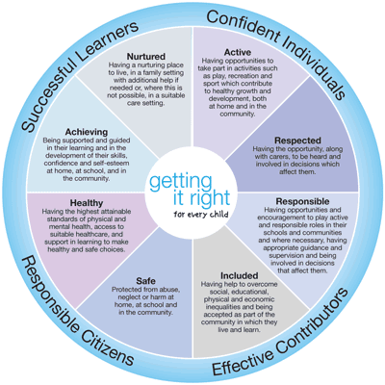

Request for Assistance Complex Care Needs

Child’s Name:
Date of Birth:
Child’s Address:
CHI:
Request from Assistance from: | Name | Role | Contact Details

Is this Request for Assistance related to Child Protection? | Yes | No
If yes, date on which you made the referral regarding Child Protection:

Request for Assistance to:
Name | Service | Contact Details
Date of any phone call to seek advice prior to completing | Date and time form completed | Name of Practitioner and Service Requesting Assistance

Is the Responsible Person aware of the Request for Assistance? | Yes | No
Has the child/parent been advised that information will be shared? Tick YES box only if communication has taken place | Yes | No
Has informed consent been given to share information with other agencies? This relates to the NHSGGC information sharing protocol and consent form | Yes | No
From child/young person | Yes | No
From Parent/Carer 1 | Yes | No
From Parent/Carer 2 | Yes | No
Decision to share information without consent | Yes | No
If you were unable to gain consent, are unsure whether consent is informed or no consent was given please provide details.

Summarise your current concern(s) including the child/young person, parent/carer views. Specify any other relevant contextual factors relating to the family which are not provided elsewhere (any Single Agency or Integrated Assessment/Plans/Chronologies should be attached)

What are you or your agency currently doing to support this child/young person? | Are you aware of concerns or actions being taken to support this child/young person by any other agency?

What are the desired outcome(s) for this child/young person of this request for assistance and what do you see as the next steps to achieve long-term outcomes?

What is the best way to make contact with you about this request for assistance? (Please include any practical issues that need to be taken into account to enable you to work with other agencies)
Contact details of Named Person
Contact Details Lead Health Professional / Care Coordinator
Contact details of Lead Professional

Please Send Copy
- Named Person
- Lead Professional
- Team Around the Child

Guidance

Request for Assistance – Complex Care Needs

Request for Assistance - Guidance

Child’s Name:
Date of Birth:
Child’s Address:
Unique Identifier: | CHI/ Date of Birth

Is this Request for Assistance related to Child Protection? | Yes | No
If yes, date on which you made the referral regarding Child Protection:
If the answer to this question is yes, please enter the date that you contacted children and families social work service to report your concern. This must be done before completing the written Request for Assistance. This will allow your colleagues to provide an appropriate, proportionate and timely response.

Request for Assistance to: specify service here
Provide information about which service/agency or professional assistance is being requested. Recipients should be able to see at a glance whether this is a generic or specific request and which other agencies/ professionals are being asked to be involved.

Date of any phone call to seek advice prior to completing | Date and time form completed | Name of Practitioner and Service Requesting Assistance
If unsure about whether a Request for Assistance is appropriate and proportionate, a telephone call may save time. | This information can be used to monitor process time and responses. | Identify the service, practitioner requesting assistance.

Is the Responsible Person aware of the Request for Assistance? | Yes | No
Has the child/parent been advised that information will be shared? Tick YES box only if communication has taken place | Yes | No
Has informed consent been given to share information with other agencies? This relates to the Inverclyde information sharing protocol and consent form | Yes | No
From child/young person | Yes | No
From Parent/Carer 1 | Yes | No
From Parent/Carer 2 | Yes | No
Decision to share information without consent | Yes | No
If you were unable to gain consent, are unsure whether consent is informed or no consent was given please provide details.
This section should reassure practitioners that ethical practice is in place and that the child/family’s rights are being respected and protected.

Summarise your current concern(s) including the child/young person, parent/carer views. Specify any other relevant contextual factors relating to the family which are not provided elsewhere (any Single Agency or Integrated Assessment/Plans/Chronologies should be attached)
Provide a concise summary of any concerns that have been identified as needing addressed by another practitioner, service or agency.

What are you or your agency currently doing to support this child/young person? | Are you aware of concerns or actions being taken to support this child/young person by any other agency?
Provide a concise summary of the actions currently taking place to support the child/young person | Any details you are aware of that could help the other practitioner, service or agency to respond appropriately should be included here.

What are the desired outcome(s) for this child/young person of this Request for Assistance and what do you see as the next steps to achieve long-term outcomes?
Detail exactly what the practitioner/child/parent/carer hope to gain from the Request for Assistance. Is it advice, a specialist assessment, a service, a specific action, short-term or long-term support? This will help the recipient to provide an appropriate, proportionate and timely response.

What is the best way to make contact with you about this Request for Assistance? (Please include any practical issues that need to be taken into account to enable you to work with other agencies)
This section ensures that time is not wasted with ineffective means of communication or approaches to communication. For example, some practitioners may only have weekly access to their emails, many clinicians arrange clinics in six-weekly cycles and this is the kind of notice they need to participate in joint or integrated meetings.
Contact details of person including contact details | Lead Professional Health/ Care Coordinator Health including contact details | Contact Details Lead Professional
If it is not the Named Person who is requesting assistance they should always be informed if assistance is being provided. | If the child/young person has a Lead Professional they should always be aware if assistance is being requested/provided. | If Social worker assigned

