A Practitioner’s Toolkit: Promoting, Supporting and Safeguarding the Wellbeing of Children & Young People in NHS GG&C
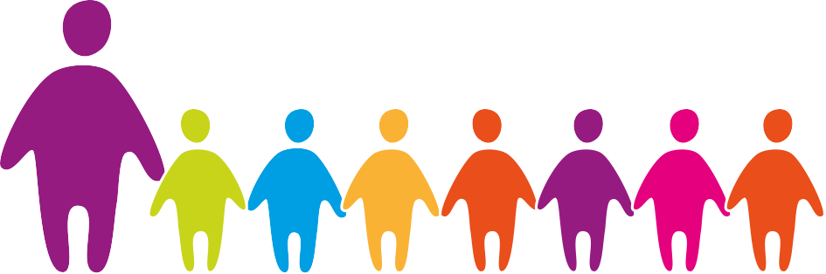

Safe
Healthy
Achieving Nurtured
Active
Respected
Responsible Included

Checklist No 2: Five Key GIRFEC Questions

Who can use this Checklist and when can it be used?
All practitioners and managers in all services/agencies can use this Checklist to reflect on any worries or concerns they may have about a child or young person’s wellbeing. This is a self-reflective Checklist.

Name of Child or Young Person |  | Age |  | Date of Birth

No | Question | Notes

1 | What is getting in the way of this child or young person’s wellbeing?

2 | Do I have all the information I need to help this child or young person?

3 | What can I do now to help this child or young person?

4 | What can my agency do to help this child or young person?

5 | What additional help, if any, may be needed from others?

What is the information telling me?

Using this Checklist, analyse the information gathered and ask yourself the key question, “what is this information telling me?”.

Consider the information gathered and identify the key risk factors for the child or young person or the parent/carer and their wider world. The Checklist will highlight the specific areas of concern/need/risk (your evidence) and should give you an overview of what you consider to be the key issues.
Now form a view as to the level of concern/need/risk for the child or young person or the parent/carer, taking account of the interaction between the child or young person or the parent/carer and their wider world.
What is the information telling you about the level of concern/need/risk?

What is the information telling me about the level of concern/need/risk? (Consider frequency, duration, severity, single or accumulative in nature - significance of factors in reaching a conclusion about the level of concern/need/risk).
What am I going to do next?

Date Completed |  | Completed By |  | Line Manager

